Mini Project Report on

**Use of Technology in Agriculture Sector**



By

Aman Kumar **(Reg.No. 201800204)**

Dhrubajyoti Choudhury **(Reg. No. 201800236)**

Rituraj Choudhury **(Reg. No. 201800338)**

### 

### In partial fulfilment of requirements for the award of the degree

**Bachelor of Technology (Information Technology)**

(2018)

*Under the guidance of*

Mrs. Chandralika Chakraborty (Assistant Professor)

**DEPARTMENT OF INFORMATION TECHNOLOGY**

**SIKKIM MANIPAL INSTITUTE OF TECHNOLOGY**

MAJITAR, RANGPO, EAST SIKKIM – 737136

**Abstract**

We have developed a website in the field of agriculture to spread and provide knowledge regarding various conditions, procedures and requirements in farming of various crops.

This website will give the quality knowledge to users, regarding farming.

This website will generally provide minimum information about cultivation process, required weather conditions, pesticide requirement etc. of the plant to be cultivated and will help the user in farming on their own way.



**SIKKIM MANIPAL INSTITUTE OF TECHNOLOGY**

*(A Constituent College of Sikkim Manipal University)*

**Department of Information Technology**

**DEPARTMENT CERTIFICATE**

This is to certify that **Mr. Aman Kumar (Regd. No. 201800204) , Mr. Dhrubajyoti Choudhury (Regd. No. 201800236) and Mr. Rituraj Choudhury (Regd. 201800236)** students of Bachelor of Technology, VII Semester, Department of Information Technology of Sikkim Manipal Institute of Technology, have pursued the Mini Project titled “**Use of Technology in Agricultural Sector**” under the supervision of **Mrs. Chandralika Chakraborty** and the report has been submitted in partial fulfilment of requirements for the award of the degree, Bachelor of Technology in Information Technology by Sikkim Manipal University in the Year

|  |  |
| --- | --- |
| *Internal Guide Mrs. Chandralika Chakraborty*  Designation: Assistant Professor  Date: --------------    *&*  --------------------  Designation: -------------  Date: -------------- | Head of the Department  Dr. Hiren Kumar Deva Sarma  Date: ----------------- |



**SIKKIM MANIPAL INSTITUTE OF TECHNOLOGY**

*(A Constituent College of Sikkim Manipal University)*

**Department of Information Technology**

**EXAM CERTIFICATE**

This is to certify that **Mr. Aman Kumar (Regd. No. 201800204)** , **Mr. Dhrubajyoti Choudhury** **(Regd. No. 201800236)** and **Rituraj Choudhury (Regd. No. 201800338)** students of Bachelor of Technology, VII Semester, Department of Information Technology of Sikkim Manipal Institute of Technology, have pursued the Mini Project titled **“Use of Technology in Agriculture Sector”** under the guidance and supervision of **Mrs. Chandralika Chakraborty** and the report has been submitted in partial fulfilment of requirements for the award of the degree, Bachelor of Technology in Information Technology by Sikkim Manipal University in the Year 20

External Examiner

Signature and Date:

Internal Examiner

Signature and Date:

**Acknowledgements**

We have taken efforts in this project. However, it would not have been possible without the kind support and help of many individuals.

We would like to extend my sincere thanks to all of them.

We highly indebted to Mrs. Chandralika ma’am and our Panel members for their guidance and constant supervision as well as for providing necessary information regarding the project and also for their support in the complete project.

I would like to express my special gratitude and thanks to our Respected HOD Dr. Hiren Kumar Deva Sarma for giving such attention and time.

**INDEX**

|  |  |  |
| --- | --- | --- |
| **Sl no** | **Chapter name:** | **Page no:** |
| 1 | Introduction | 8 |
| 2 | Software requirement specification | 21 |
| 3 | Design | 22 |
| 4 | Implementation details | 31 |
| 5 | Results and Discussions | 33 |
| 6 | Summary and Conclusions | 43 |
| 7 | Bibliography | 44 |
| 8 | Plagiarism report |  |

**CHAPTER 1: INTRODUCTION**

1. **Introduction**

In today’s context, technologies have been evolving over time specifically in the field of computer science. Technologies have been playing a vital role in Agriculture, health, defence and military, research and many more areas.

Technologies have played a vital role in the field of agricultural sector as well to boost up the production as well as to improve the most efficient and eco-friendly ways to cultivate a crop.

***1)Various Technologies Used in agriculture sector are:***

*\**Use of Artificial intelligence, Big data , IoT, Machine learning and many more

*Monitoring and controlling crop irrigation systems via smartphone

*Usage of mobile technology and cameras, Crop Sensors, Drone Surveillance, etc.

***2)Their influences after using these technologies are:***

*Faster Production

*Increase of work safety

*Reduce impact in natural ecosystem i.e efficient use of fertilisers and pesticides, conservation of water and electricity, etc.

In this project we have developed a website to provide the bare minimum instructions and knowledge in a procedural manner of how to implement cultivation practices. This website also includes database management system to help in monitoring crop storage for users. Another feature of this website is to estimate favourable conditions and needs of a particular crop that the user wants to plan or cultivate. By ‘conditions and needs’ we mean season, month of start, month of harvesting, favourable weather conditions, cost of production and overall time period to cultivate the crop.

* 1. **General Overview of the Problem**

Since most of the citizens are unaware about cultivation processes or due to lack of information and guidance, most people tend to ignore the importance of Agriculture sector. Therefore, the website will give the user information regarding cultivation of various crops. Also various government schemes are provided to fund the BPL(Below poverty line) people.

* 1. **Literature Survey**

|  |  |  |  |  |  |  |
| --- | --- | --- | --- | --- | --- | --- |
| Title of Article(Article’s Heading) | Author | Published in | Year | Method used/Proposed(In that particular article which methods are proposed) | Result obtained/Accuracy(What are the results and influences after using that methods) | LINK |
| Role of Information Technology in Agriculture | Arun-Raj | OrysisIndia | Nil | The IT infrastructure development is imperative. The vital objective in fulfilling the idea is to avail the access of computers and its accessories to the targeted group, i.e. the farmers from remote rural areas across the country. | India has made rapid progress in state of the art technology where to make a call for an action, plans can be laid out using remote sensing, geographic information systems (GIS), bioengineering, satellite technology etc. Using remote sensing and GIS applications effective agricultural exhibition is possible to keep an eye on. Crop stress, soil problems, challenges, natural disasters etc. can be effectively tackled using this technology. | [Role of Information Technology in Agriculture - OrisysIndia](https://orisys.in/role-of-information-technology-in-agriculture/) |
| Indian Agriculture, farmer’s Lives and initiative by technology companies to make their lives Better | MohitVerma | Brill-Infosystems | May-29-2019 | * Precision farming*Artificial Intelligence*Agriculture and Big Data*Role of Technology Companies* Farm Mechanization | * Increase in the productivity per unit of land is the key to enriched agricultural growth. Precision farming practices can help farmers get more precision based data like the use of the type of seeds, the number of seeds, nutrients, fertilizers and irrigation per unit of land  * The development and deployment of AI in agriculture are on the increase due to the availability of the precision data. AI-based modern and high-tech tools can help get precision to large-scale agriculture.  * Big data can help forecast weather, soil conditions, GPS maps, water resource availability, community market condition, demand-vs-supply and raw input cost.  * Top technology leaders like Microsoft, TCS, and other players are already working on the various products for the Indian Agriculture. AI-based Sowing App has been developed by Microsoft. **mKrishi**is being developed by Tata Consultancy Services (TCS) Innovation Labs. ***Smart Farms, by CropIn Technologies,*** provides the cloud-based platform which is supported Mobile App to track the growth of crops on diversified locations around India.  * Computerized farm machinery can be applied for cultivation, sowing, spraying, fertilizers and pesticides; and harvesting etc. Electronic sensors help automatic feeding and monitoring of the farm animals. This equipment can be controlled by GPS trackers, IoT devices and mobile apps for timeliness and getting precision. Remote controlled sprayers, sowers and irrigation devices can help change the traditional agricultural practices in India. | https://www.brillinfosystems.com/blog/2019/05/29/role-of-technology-in-transforming-indian-agriculture/ |
| Relationship between Technology and Agriculture in India | Puja Mondal | Your-article-Library | Nil | 1.Green Revolution.  2.agriculture has been highly mechanized.  3.Even artificial rain has been used To modernize Agriculture farming.  3. Hybrid varieties of seeds were made available to the farmers. | 1.The process of harvesting, which used to be months’ long involving a large number of people have been reduced to a few days’ work without engaging any major manpower.  2 Artificial rain has been made possible now to provide relief to the drought-hit villages  3.The use of technology has reduced the risk factors in agriculture  4.Technology has reduced farmer’s dependency on, and vulnerability to, the nature. | [Relationship between Technology and Agriculture in India (yourarticlelibrary.com)](https://www.yourarticlelibrary.com/essay/relationship-between-technology-and-agriculture-in-india/30721) |
| Importance Of Technology In Indian Agriculture | Kailashchoudhary | The Hitavada the peoples paper | 30-August-2020 | *The Central government has provided new financial packages to the agriculture sector to provide them all possible help and the targets of the government to double their income could be achieved.  *Nano Science  *Geo Spatial Farming  *Drones | *The government is promoting agri-business with a view to provide maximum benefit to the farmers. Amazon, Alibaba, E-bay and Walmart E-commerce agencies have brought revolutionary changes through artificial intelligence and machine learning.  *In line with the revolution of Ecommerce, a platform of E Agri/digital agriculture is being prepared with the help of which agri-business schemes will reach the major urban and town areas. Home delivery agencies like Big Basket and Grofers have helped in paving the way to develop beneficial agri-business for their own with the help of agriculture specialists.    *Green farm house, poly house and small bio farms for growing vegetables etc are becoming beneficial for the farmers due to their quality and fair prices.  ***\*Nano Science:*** This is a technique which provides information to the farmers through use of smart delivery system and nano sensors as to whether or not plants are receiving water and other necessary inputs in adequate quantity. Besides, it also provides information about the quality of food produced.  ***\*Geo Spatial Farming:*** By adopting geo spatial farming, agricultural production can be increased on a large scale. Higher production can be achieved on the basis of factors like weeds, quality of soil and its moisture content, production (fertility), rate of seeds, need of fertilisers and other such factors.  ***\*Drones:*** They help in increasing production by reducing costs and loss in agricultural produce by supervision work. Advanced sensors, capability of digital imaging, soil analysis, crop spraying, crop monitoring, analysis of health of crops including fungus infection is possible with the help of drone technique. | [Importance Of Technology In Indian Agriculture - The Hitavada](https://www.thehitavada.com/Encyc/2020/8/30/Importance-Of-Technology-In-Indian-Agriculture.html) |
| Major Impacts of Technology on Rural Society of India | Puja mondal | Your-article-Library | Nil | *Improved Implements*New Agricultural Inputs | *The tractor, lorry, thresher and a large number of techniques have been given to the vil­lage people. There are some parts of our country such as Punjab, Maharashtra and Gujarat where the use of bullocks has become oblivi­ous. Bullock-cart has also become outdated. All this clearly shows the role played by new technology.  The electric or diesel oil-run water pumps have revolutionised the old pattern of irrigation. The construction of dams major and minor has also added great facili­ties of irrigation. The chemical manure and insecticides have added much to the farm produce. | https://www.yourarticlelibrary.com/essay/major-impacts-of-technology-on-rural-society-of-india/32011 |
| Technical Change In Agriculture, 1952–2000 | Nil | Encyclopedia.com | Nil | 1.India's first [Five-Year Plan](https://www.encyclopedia.com/history/modern-europe/russian-soviet-and-cis-history/five-year-plan) 2.Land reclamation and development3.Irrigation | 1.Under India [Five-Year Plan](https://www.encyclopedia.com/history/modern-europe/russian-soviet-and-cis-history/five-year-plan). Focus was placed on expansion of irrigation, land reclamation, and the domestic production of inorganic fertilizers.  2.Reclamation of nearly 25 million acres (10 million hectares) of land was set as a target, and land reclamation was undertaken on a large scale across India.Consequently, the net area sown had gone up from about 297 million acres (120 million hectares) in 1952–1953 to about 341 million acres (138 million hectares) in 1966–1967, and the respective annual average growth rates (net as well as gross area sown) were the maximum during the 1950s, compared to any other period  3.A number of major irrigation projects were completed during the first [Five-Year Plan](https://www.encyclopedia.com/history/modern-europe/russian-soviet-and-cis-history/five-year-plan), including the Tungabhadra Project (1956), Maithon (1957), Konar (1955), Kakarpara (1957), Gandhi Sagar (1960) etc. | [Technical Change in Agriculture, 1952–2000 | Encyclopedia.com](https://www.encyclopedia.com/international/encyclopedias-almanacs-transcripts-and-maps/technical-change-agriculture-1952-2000#:~:text=Technological%20changes%20in%20the%20form,compared%20to%20that%20of%20wheat.) |
| How technology is making Indian agriculture smarter, inclusive and more resilient. | Team YS | Your Story | 10th Dec 2020 | 1.Latest technologies such as Artificial Intelligence (AI), Machine Learning (ML), and Cloud   2. India’s National Strategy on AI recognises agriculture as a priority sector for implementation of AI-driven solutions. According to the Niti Aayog, AI in agriculture is expected to grow at a rate of 22.5 percent CAGR, and is likely to be valued at $2.6 billion by 2025.  3. In recent years, the impact of climate change on the agriculture sector has been more pronounced. | 1.Use of these technology offer them greater climate resilience, higher crop yield, and better price control.  2.Smart farming that uses modern digital technologies such as sensors, location data derived from GPS and satellites, robotics and analytics is changing the face of agriculture in India.  3.AI can help farmers predict weather patterns. Big Data helps improve the yield, reduces risk, and increases efficiency. With the right data, farmers will be able to take timely decisions, on what crop to sow, when to sow it, and what method to use. | <https://yourstory.com/2020/12/technology-making-indian-agriculture-smarter-inclusive-resilient> |
| Applying modern tech to agriculture | [Nidhi Sharma,](https://www.downtoearth.org.in/author/nidhi-sharma-144368)[Amit Kumar Mungarwal](https://www.downtoearth.org.in/author/amit-kumar-mungarwal-134775) | Down to Earth | 5-august-2019 | 1. **Monitoring and controlling crop irrigation systems via smartphone.** 2. **Ultrasounds for livestock.** 3. **Usage of mobile technology and cameras.** 4. **Crop Sensors.** | 1.Here farmer can control his irrigation systems from a phone or computer instead of driving to each field.Moisture sensors in the ground are able to communicate information about the level of moisture present at certain depths in the soil.  2.Ultrasound is not only for checking on baby animals in the womb. It also can be used to discover what quality of meat might be found in an animal before it goes to the market.  The testing of DNA helps producers to identify animals with good pedigrees and other desirable qualities. This information can also be used to help the farmer to improve the quality of his herds.  3. Farmers can also put up cameras around the farm to keep a closer eye on the animals when they are away or home for the night.  4. Crop sensors help apply fertilisers in a very effective manner they also see how much fertiliser a plant may need, based on the amount of light reflected back to the sensor. | [Applying modern tech to agriculture (downtoearth.org.in)](https://www.downtoearth.org.in/blog/agriculture/applying-modern-tech-to-agriculture-66017) |
| How new technologies can raise productivity | **SambuddhaGoswami**  [**Uma Lele**](https://www.ideasforindia.in/profile/uma.html) | Ideas For India | * 06 December- 2017 | 1.**Unsustainable water usage.** 2. Digital technology. | 1.Agriculture, which accounts for 70 percent of water withdrawals worldwide, plays a major role in water pollution this can be controlled using latest technology.  2. Digital technology can guide crop and input selection, facilitate credit and insurance, and provide weather advisories and disease- and pest-related assistance, and real-time data on domestic and export markets. | [How new technologies can raise farm productivity (ideasforindia.in)](https://www.ideasforindia.in/topics/agriculture/how-new-technologies-can-raise-farm-productivity.html) |
| Innovations required for successful Indian agriculture in future | Nil | Agro-Spectrum | * 28 November 2019 | 1. **Requirement of start-ups in agriculture(agripreuneurs)** 2. **Transforming food processing economy.** 3. **Scope of technology intervention** | 1.India has made a strong name for itself in the global start-up community. It ranks amongst the top five countries in the world in terms of number of start-ups founded. It is estimated that India houses less than 5000 start-ups, creating more than 1,00,000 employment opportunities. By 2021, the number of start-ups in India is projected to increase to more than 12000, with job creation from these entrepreneurs reaching 300,000-400,000 by 2021.  2.Status and sectoral presence of agri start-ups in India is- Supply chain • E-distributor • Listing platform • Marketplace Infrastructure • Growing system and components • Aquaponics • Hydroponics • Drip irrigation Finance • Payments • Revenue sharing • Lending Farm data and analytics • Integrated Platform • Remote sensing software platforms • Farm mapping • Farm management solution • Field operations • Information dissemination  3.Value Chain Stage Technology Intervention required in - Inputs / Knowledge • Getting agriculture inputs directly on phone • Weather forecast through weather apps • Decision support solution for farmers like selling crops at appropriate rates • Pest Management Solution and Nutritional Management Solution • AI based sowing advisories Harvesting and Transport • GSM Mobile controlled motor • Hi tech irrigation systems like drip, sprinkler etc. • Auto Steering Tractors powered by GPS • Crop Counting Machines • Machine-learning algorithms to differentiate between weeds and crops Processing and Storage • Machine based Imaging technology to sort based on colour, size, type etc. • Wireless sensor to monitor crops connected with smartphone • Measuring grains moisture content Distribution, Packaging and Handling • Web and mobile applications to sell directly farm products • Price forecasting model to prevent inflation • Dynamic product pricing • Online marketplace for grain • Using data to track | [Innovations required for successful Indian agriculture in future (agrospectrumindia.com)](http://www.agrospectrumindia.com/analysis/30/180/innovations-required-for-successful-indian-agriculture-in-future.html) |
| Technology in Agriculture | Jaydev Jana | The Statesman | 31 October 2020 | 1)Nano formulations of agrochemicals for applying pesticides and fertilizers for crop improvement;  (2) plant disease diagnosis;  (3) postharvest management etc. | Nano sensors and nano-based smart delivery systems could help in efficient use of agricultural natural resources like water, nutrients and chemicals through precision farming. | https://www.thestatesman.com/opinion/technology-in-agriculture-1502932835.html |
| Technology: The future of agriculture | Antony King | Nature | 27 April 2017 | A technological revolution in farming led by advances in robotics and sensing technologies looks set to disrupt modern practice. 1.Ripe for the picking2.Eliminating enemies (by drones)3. Animal trackers | 1. an agricultural engineer at Wageningen University in the Netherlands, who is working on a sweet-pepper harvester. The challenge is to quickly and precisely identify the pepper and avoid cutting the main stem of the plant. The key lies in fast, precise software. “We are performing deep learning with the machine so it can interpret all the data from a colour camera fast,” says van Henten. “We even feed data from regular street scenes into the neural network to better train it.”  2. “The market is demanding foods with less herbicide and pesticide, and with greater quality,” says Red Whittaker, a robotics engineer at Carnegie Mellon who designed and patented an automated guidance system for tractors in 1997. “That challenge can be met by robots.”  3. Smart collars — a bit like the wearable devices designed to track human health and fitness — have been used to monitor cows in Scotland since 2010. Developed by Glasgow start-up Silent Herdsman, the collar monitors fertility by tracking activity — cows move around more when they are fertile — and uses this to alert farmers to when a cow is ready to mate, sending a message to his or her laptop or smartphone. | https://www.nature.com/articles/544S21a |
| Digitisation In Agriculture: A Necessity For India | Nil | BW Buisnessworld | 10 April 2021 | ***\*digitisation***  ***\*sensor-assisted soil assessment***  **\**automated monitoring of free-ranging animals on pastures, and the targeted control of agricultural machinery***  ***\*nanotechnology*** | **Digitisation and agriculture have massive potential, despite this, several issues have to be addressed before this can be widely adopted and successfully executed:**  **· The natural soil biology can be destroyed if technology is not used with caution. Soil erosion must never result from the proper use of technology, especially on large agricultural areas. This is highly likely to happen when the farmer is not educated in technology and soil science, which is the experience in India.**  **Use of digital technology requires efficient and reliable power supply that reaches to every nook and corner of farming community in general and farmers. The electrical connectivity is as important as digital connectivity.** | http://www.businessworld.in/article/Digitisation-In-Agriculture-A-Necessity-For-India/27-01-2021-370573/ |
| Latest agriculture technologies in INDIA, impact advantages. | Jagdish Reddy | Agri-Farming | 25 February 2020 | 1. Artificial Intelligence  2. Mobile Applications  3. Animal Tracking  4. Soil an Water sensors  5. Irrigate via smartphone  6. RFID technology | 1. Disruptive technologies like AI are making big positive changes across Indian agriculture, and an increasing number of Agri-tech start-ups in the country are working to develop and implement AI-based solutions. Globally, AI applications in agriculture reached a valuation of $852.2 million in 2019 and this is estimated to grow to almost $8.38 billion by 2030, a nearly 25 per cent growth. The Indian Agri-tech market, presently valued at $204 million, has reached just 1 per cent of its estimated potential of $ 24 billion.  2. There are apps for social networks, banking, travel, health, fitness, news, calendars, games, you name it, there is sure to be an app there for Agriculture. The use of Information and Communication Technology (ICT) to support the transmission of localized information and services working towards making farming socially, economically and environmentally sustainable, while contributing to the delivery of nutritious and economical food for all – this comprises the Digital Agriculture.  This has also led to the rise and development of mobile apps which are helping existing government schemes and other agriculture-based information to reach farmers in rural India. This digital change is acting as a game-changer for Indian agricultural conditions. Thus, the apps are helping boost overall business performance and reducing negative environmental impacts of farming. Now, with a click of a button, farmers can access information regarding weather, dealers, market prices, plant protection, agro advisories, IPM practices etc. Thus, these advancements will definitely help bring significant change in the lives of farmers and the field of agriculture. Eg. Kisan-Suvidha,Pusa-Krishi,Agri-Market etc.  3. Mobile technology is playing an important role in monitoring and controlling crop irrigation systems. With this modern technology, a farmer can control his irrigation systems from a phone or computer instead of driving to each field.  Moisture sensors in the ground are able to communicate information about the level of moisture present at certain depths in the soil.  4. Soil moisture monitoring can be useful as an irrigation management tool for both landscapes and agriculture, sometimes replacing an evapotranspiration-based (ET) approach or as a useful check on ET-based approaches since the latter tend to drift off target over time. All moisture sensors, also known as soil water sensors, measure a response to some soil property that is related to water content. A calibration equation is used to convert the measurement into a soil moisture estimate. Often the calibration is internal to the sensor or sensing system. Although individual sensors are available, the market is demanding moisture sensing systems that feed data into a central point using either wired or wireless telemetry. Sensing systems may be tied into a decision support system that further processes the data to provide an irrigation recommendation or even control an irrigation valve or system directly.  5. IMD is implementing operational agrometeorological schemes across the country under a five-tier structure:   * Top-level policy planning body in Delhi * Execution by the National Agromet Service headquarters in Pune * Coordination and monitoring by State Agromet Centres * Definition of the agro-meteorological zone * District or local level extension and training for input management advisory service   6.RFID usage helps to monitor health of the herd, keep individual medication and vaccination records, and prevent the spread of disease by tracking and segregating infected livestock at early stages, leading to successful isolation and treatment that saves the rest of the herd and maintain the quality of respective animal meat . Therefore, RFID helps to improve farm management through increased efficiencies, reduced feed and labor costs, enhanced output and improved herd health. | [Latest Agriculture Technologies in India, Impact, Advantages | Agri Farming](https://www.agrifarming.in/latest-agriculture-technologies-in-india-impact-advantages) |
| Indian Agriculture goes Hi-Tech with New Technologies like AI, ML and IoT. | RadhikaUdas | Express-Computer | 15 January 2020 | What are the new technologies in agriculture in India?1.Artificial Intelligence2.Mobile Applications3.Big Data Analytics | 1.PradhanMantriFasalBimaYojana (PMFBY) will be welcoming **AI technology** to reduce the time consumption in settling claims of the farmers. The government also signed anMoU with IBM to monitor the agriculture sector with AI.  2. The government has majorly focused on backing the use of technology in agriculture with E- Nam (National Agriculture Market) an electronic trading portal for agricultural commodities.  There have been individual initiatives taken by some states that benefit farmers.  For example, Punjab introduced ‘Punjab Remote Sensing Centre (PRSC) that sensitizes farmers on crop residue burning and measuring air quality.  It has 3 applications under it- i-Khet Machine, e-PeHal, and e-Prevent.  3.One of the things that big data analytics solves for the agriculture industry is giving real-time insights. It will help farmers immediately identify if their techniques are working, are their inputs correct and what do they need to prepare for in case of weather changes.  When they are able to draw out valuable insights from this information, they will be able to serve their customers on a timely and customized basis. | [Indian Agriculture goes Hi-Tech with New Technologies like AI, ML and IoT - Express Computer](https://www.expresscomputer.in/features/indian-agriculture-goes-hi-tech-with-new-technologies-like-ai-ml-and-iot/45432/) |

* 1. **Analysis of the problem**

To overcome the problems of the farmer , the existing farming system will need to be evolved. The website will help and provide a quality knowledge for cultivation process for a crop , basic requirements and will give a futuristic planning for efficient practice of cultivation process.

**The following are the objectives of the project:**

* Will Provide all the updated government schemes for

farmers.

* Provides knowledge and information for plantation and

growth of crop.

* Provides a crop management database system for keeping

a track on production , which can be updated and deleted

if wanted.

* Gives a futuristic planning and estimation for cultivation

, for no chances of failures to be occurred.

* 1. **Gantt Chart**

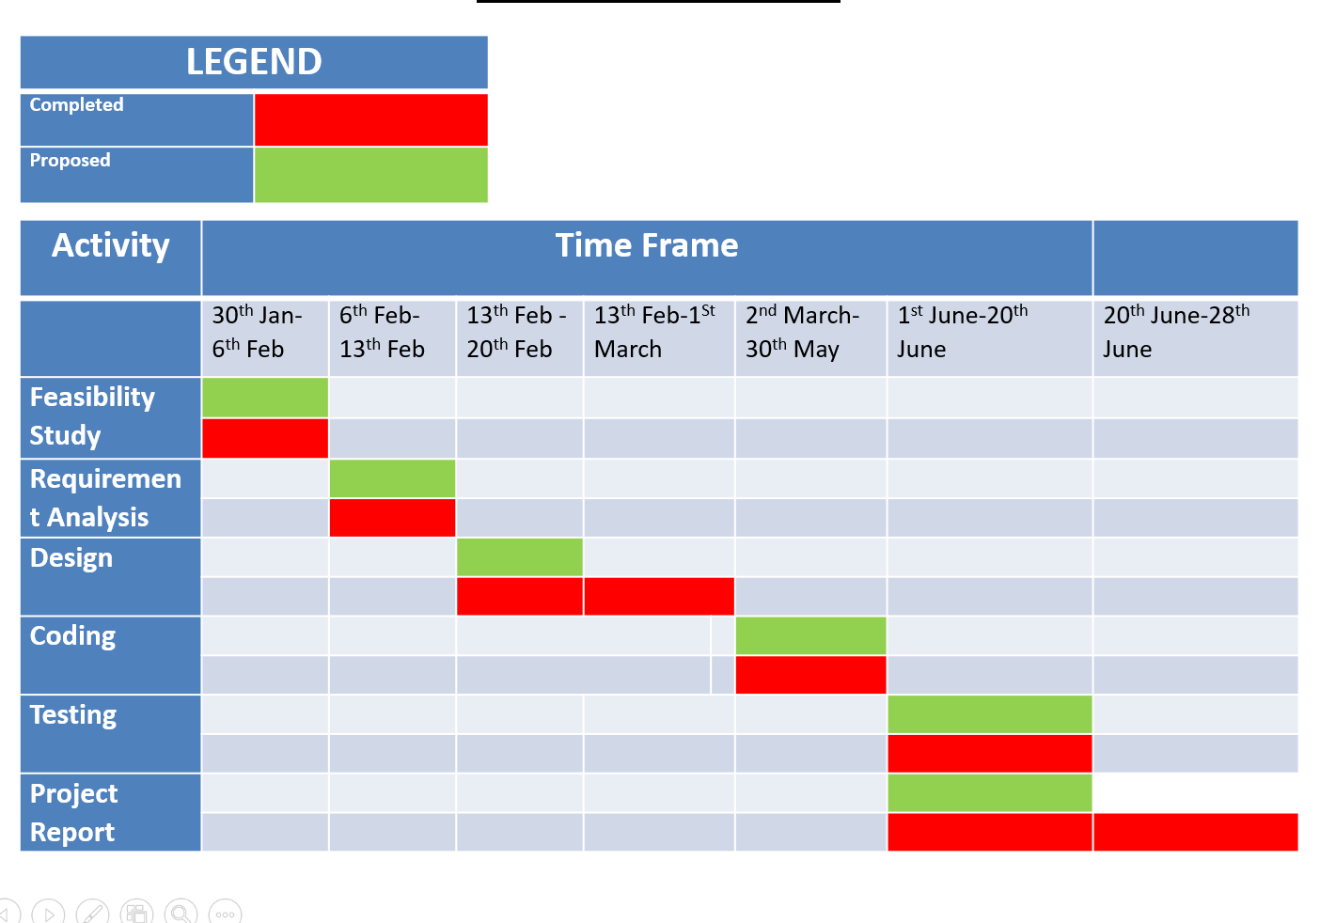

* 1. **Software Life cycle model used**

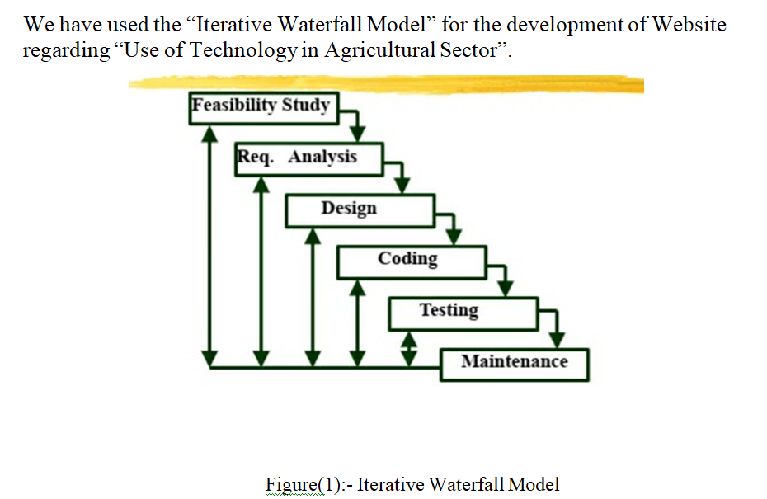

**1.6 Organization of the report**

**Chapter 1:**  Introduction

**1.1:**  General Overview of the Problem

**1.2:** Literature Survey

**1.3:** Analysis of the Problem

**1.4:** Gantt Chart

**1.5:** Software Life cycle model used

**1.6:** Organization of the Report

**Chapter 2:**  Software Requirements Specification.

**Chapter 3:** Design (*DFD, ERD, Database structure, Schema*

*diagram*)

**Chapter 4:** Implementation Details (*Algorithm*)

**Chapter 5:**  Results and Discussions (*Graphs/Bar Diagrams etc.*

*may be given*)

**1)**General overview of the webpage

**2)**Results of the page:

**2.1) Fig1:** Sign in page

**2.2) Fig2:** Log in page

**2.3) Fig3:** Index page

**2.2.1) Fig3.1:** Instruction and knowledge

**2.2.2) Fig3.2:** Government Schemes

**2.2.3) Fig3.3:** Crop Management

**2.2.4) Fig3.4:** Planning and estimation

**2.2.5) Fig3.5:** About Us:

Log out:

**Chapter 6:** Summary and Conclusions

**6.1:** Summary of Achievements

**6.2:** Major Difficulties Encountered

**6.3:** Limitations

**6.4:** Future Scope of the Work

**Chapter 7:** Bibliography

**Chapter 8:** Plagiarism Report (*Similarity Check <10%)*

**Chapter 2: Software Requirements Specification**

Language: - HTML , CSS and JAVA-SCRIPT .

Backend:-MySQL , PHP.

Server: - Tomcat Apache 7.0

Operating System: - Windows 10

Browser:- Google Chrome, edge, Firefox, Safari.

**Chapter 3: DESIGN**

***Front end:***

***Data flow diagram(DFD):-***

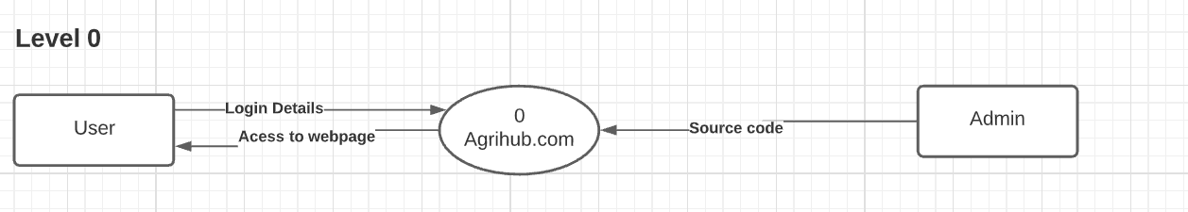

Fig: Level 0 DFD

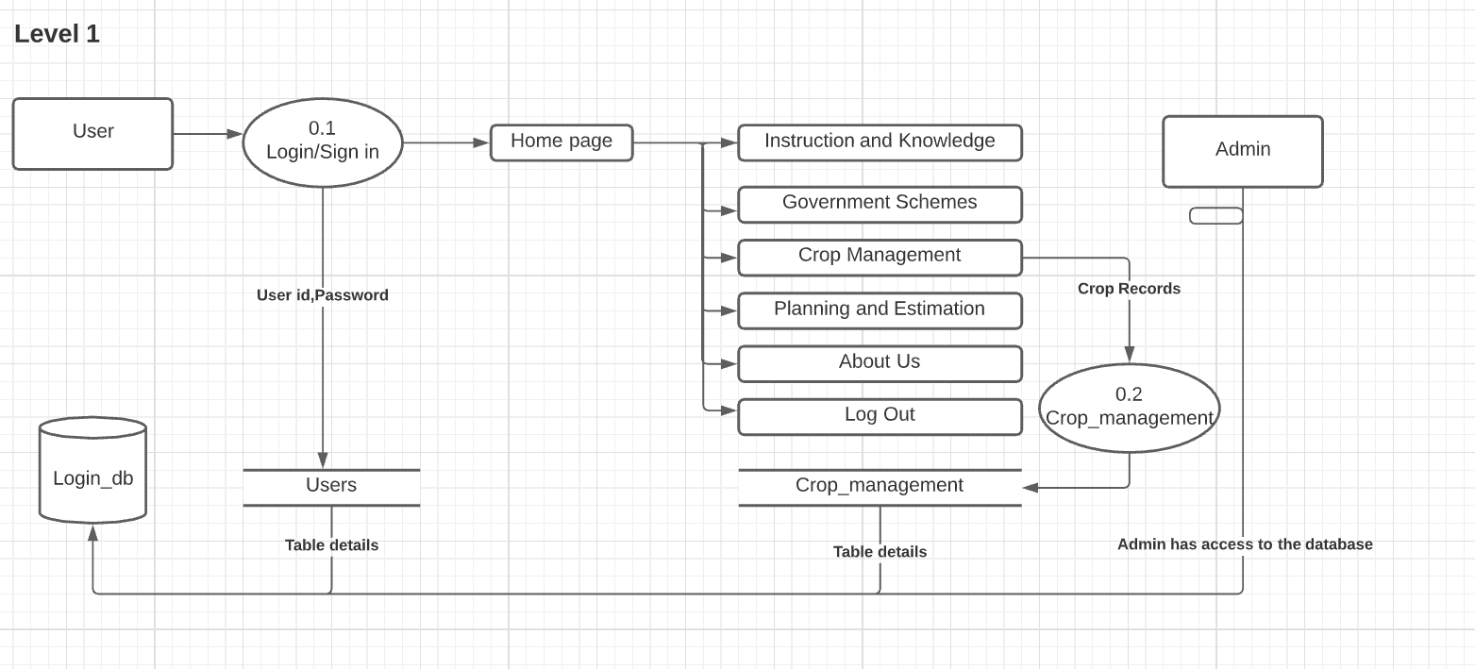

Fig: Level 1 DFD

***P.T.O***

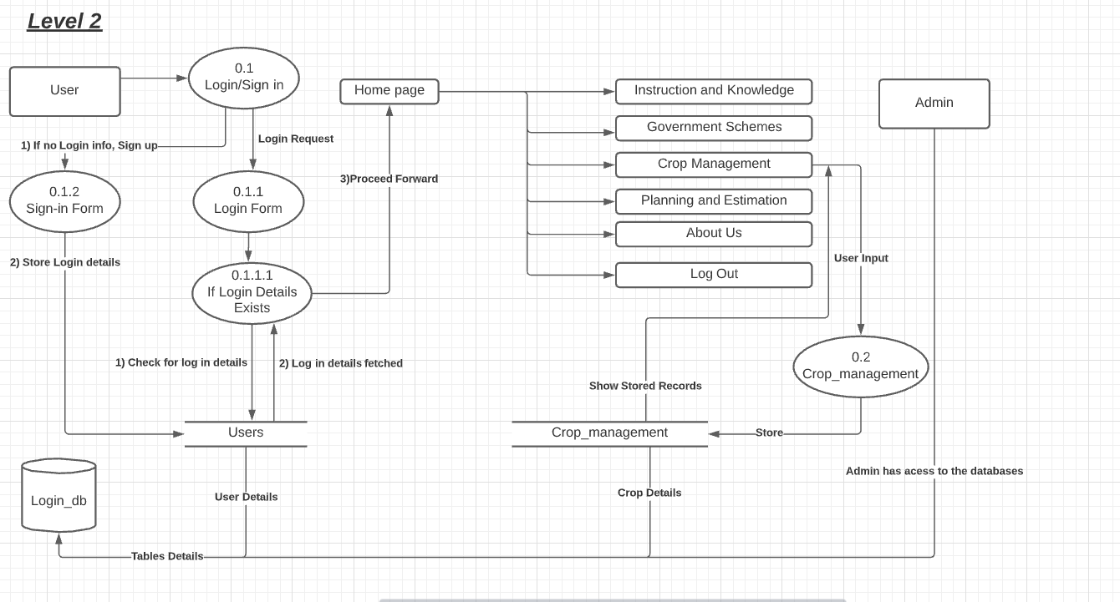

Fig: Level 2 DFD

**P.T.O**

**Estimated Design:**

No Account ? Sign in

User

DATABASE:E

Login

Sign in

**Login_db:**

**Table:** Users

After signing in

INDEX

PLANNING AND ESTIMATION

CROP MANAGEMENT

INSTRUCTION AND KNOWLEDGE

GOVERNMENT SCHEME

Figure:1

Figure:1.1

**Government Schemes:**

**\*Pradhan Mantri fasal bima yojana**

**\*National mission for sustainable agriculture**

**\*Pradhan Mantri Krishi Sinchai Yojana**

**\*Paramparagat Krishi Vikash Yojana**

**\*Micro Irrigation Fund Scheme**

**\*Mission organic value chain development for north-eastern region**

**\*E-Nam**

**\*Kisan credit card**

**\*Soil health card**

**\*pm kisan Samman Nidhi yojana**

**\*Pm-Kusum**

INDEX

PLANNING AND ESTIMATION

CROP MANAGEMENT

INSTRUCTION AND KNOWLEDGE

GOVERNMENT SCHEME

Figure:2

Figure:2.1

Flower

Pulses

Vegetable

Fruits



INDEX

GOVERNMENT SCHEME

|  |  |  |  |  |  |
| --- | --- | --- | --- | --- | --- |
| **Crop name** | **Date of production** | **Production Amount** | **Total Production till date** | **Update** | **Delete** |
| Apple | 2021-20-5 | 150kg | 200kg | update | Delete |
| Banana | 2021-06-9 | 200kg | 300kg | update | Delete |

Figure:3.1.1

**Login_db:**

**Table:** Crop_management

DATABASE:E

Crop Management System

Enter Crop name:

Date of Production:

Production Amount:

Total Production till date:

PLANNING AND ESTIMATION

CROP MANAGEMENT

INSTRUCTION AND KNOWLEDGE

Figure:3.1

Figure:3

INDEX

***Back end:***

PLANNING AND ESTIMATION

CROP MANAGEMENT

INSTRUCTION AND KNOWLEDGE

GOVERNMENT SCHEME

Figure:4

Figure:4.1

The main objective of this section is to maximize the net incomes of the farmer through improved resources, using future planning.

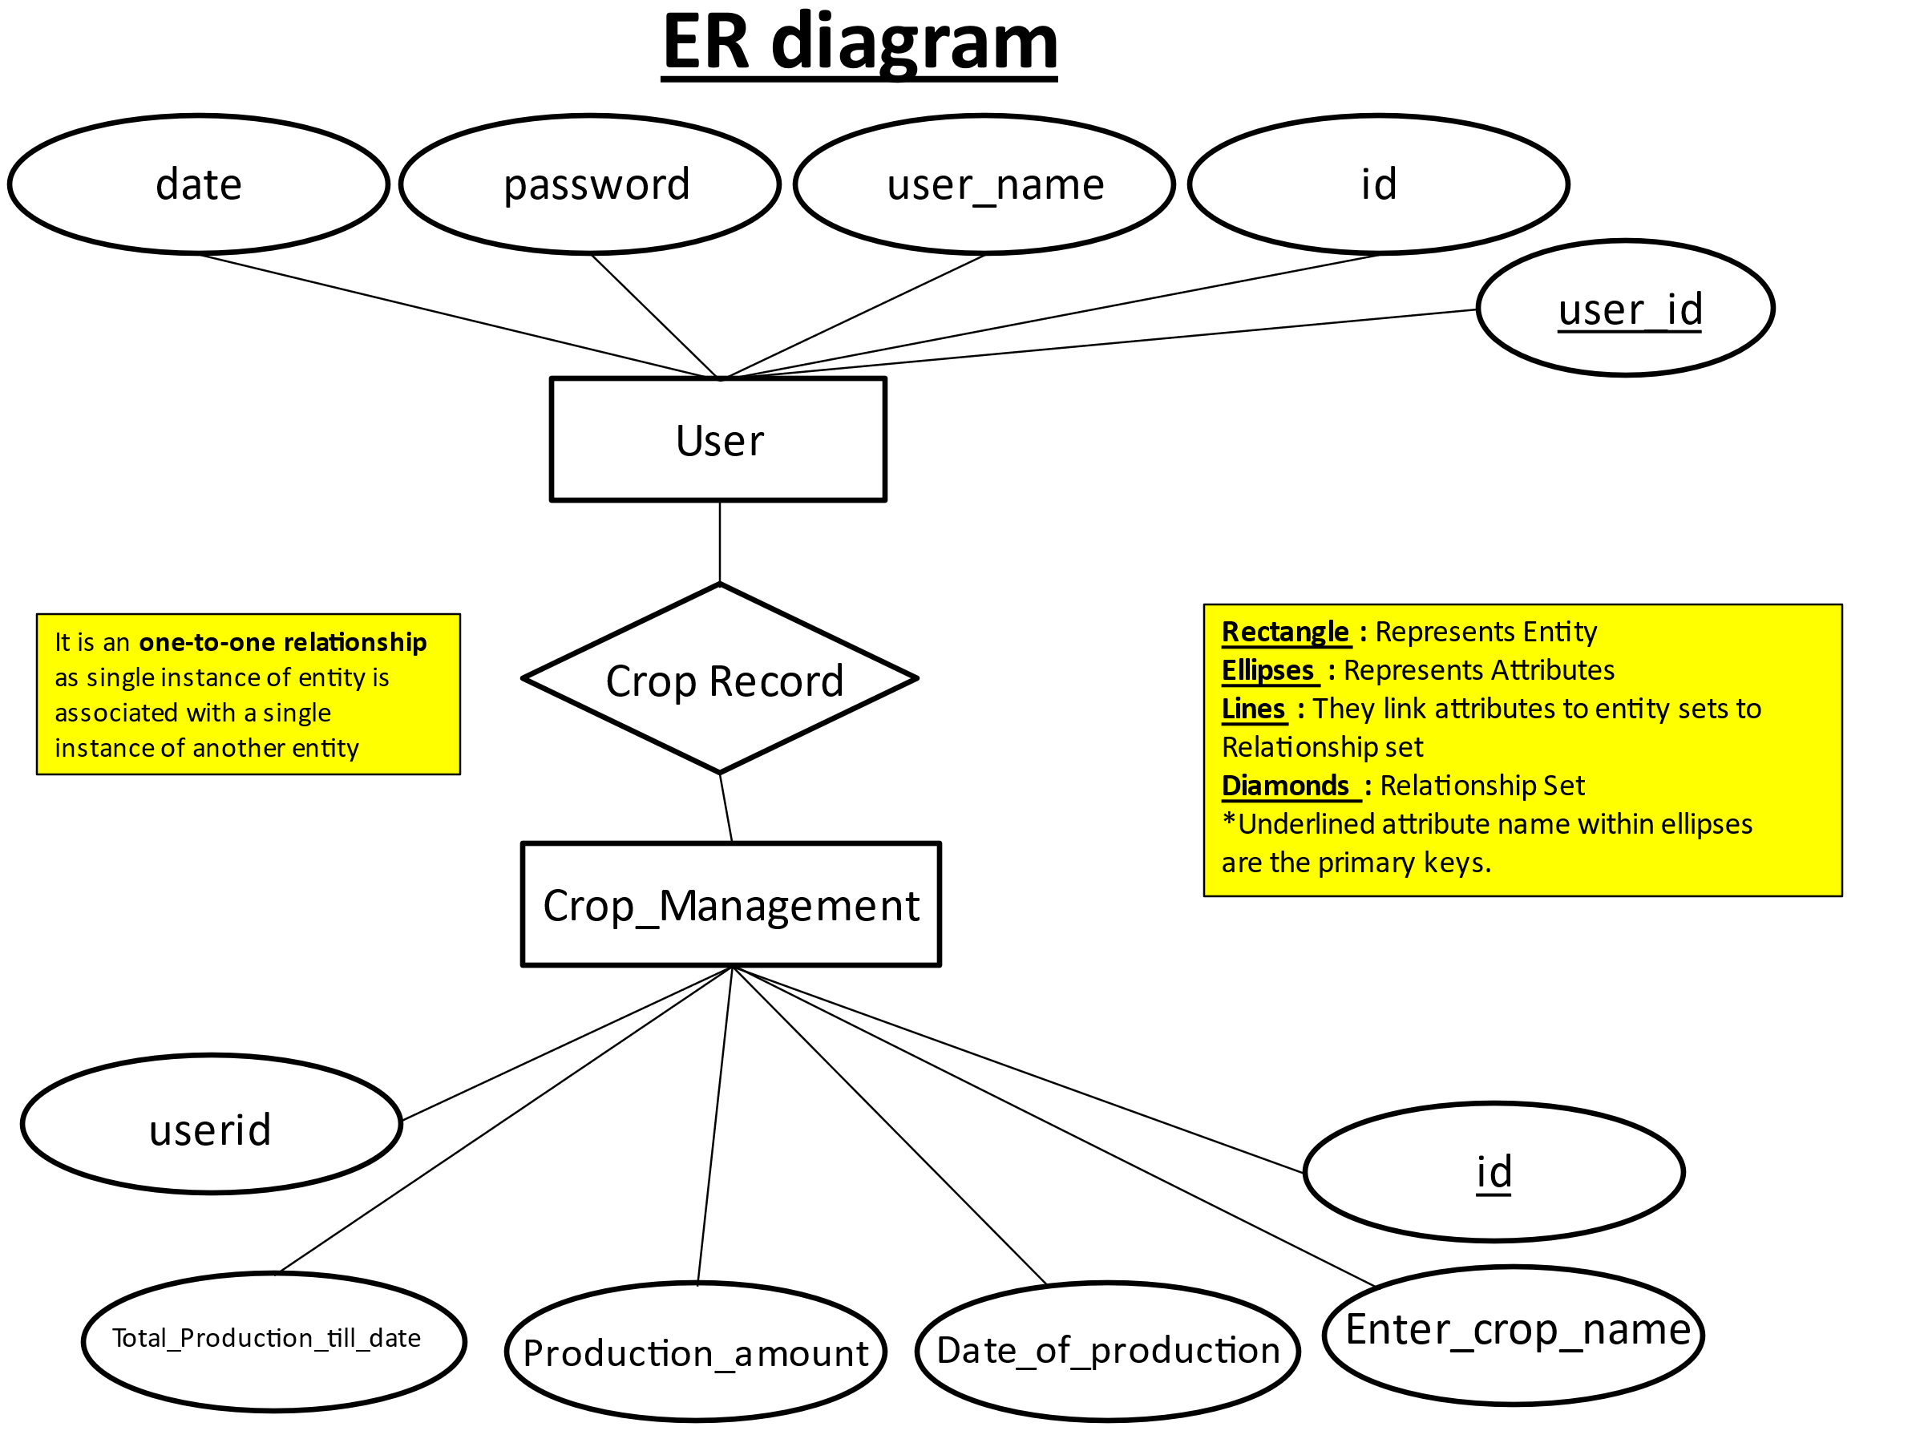

Fig: ER Diagram for Database

Martin ERD Diagram:

USER

🡪Id

🡪User_Id

🡪User_name

🡪Password

🡪Date

ID

CROP_MANAGEMENT

🡪Crop_Name

🡪Date_of_Production

🡪Production_Amount

🡪Total_Production_till_Date

Figure 6

**Database Structure:**

**Database name:**  Login_db

Describe users;

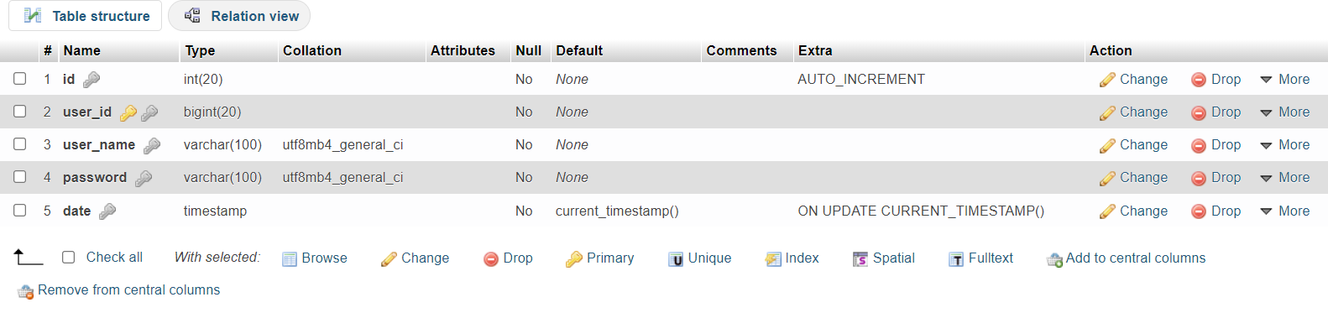

Fig: Table Structure for users

Describe Crop_management;

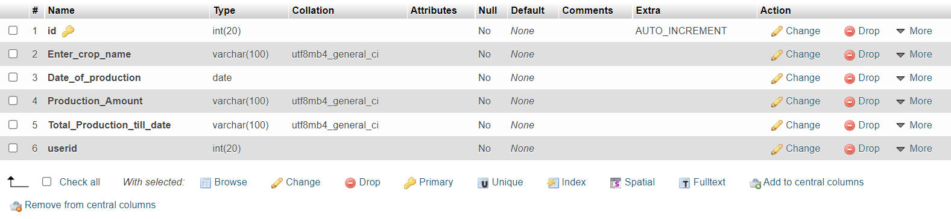

Fig: Table Structure for Crop_management

**Schema Diagram:**

Users

|  |  |  |  |  |
| --- | --- | --- | --- | --- |
| Id | User_id | User_name | Password | Date |

Crop_Management

|  |  |  |  |  |
| --- | --- | --- | --- | --- |
| Enter_Crop_name | Date_of_production | Production_amount | Total_date_of_production | User_id |

**Chapter 4: Implementation details**

**Algorithm**

**Step 1**: Start.

**Step 2**: Login.

**Step 2-1**: If valid id and password go-to step 3.

**Step 2-2**: If not valid id and password Click Sign in for login id and password and then Sign up.

**Step 3:** Entered in Index or Home page.

**Step 3-1**: If Clicked About us.

**Step 3-1-a**: Information about the Web developer.

**Step 3-2:** If Clicked Government Schemes.

**Step 3-2-a**: Government Schemes :

*Pradhan Mantri fasal bima yojana

*National mission for sustainable agriculture

*Pradhan Mantri Krishi Sinchai Yojana

*Paramparagat Krishi Vikash Yojana

*Micro Irrigation Fund Scheme

*Mission organic value chain development for north-eastern region

*E-nam

*Kisan credit card

*Soil health card

*pm kisan Samman Nidhi yojana

*Pm-Kusum

**Step 3-3:** If Clicked Instruction and Knowledge

**Step 3-3-a:** Listing of:

🡪Fruits

🡪Vegetable

🡪Pulses

🡪Flower

**Step 3-4:** If Clicked Crop Management System

**Step 3-4-a:** Enter:

Enter Crop name.

Date of Production.

Production Amount.

Total Production till date.

**Step 3-4-b:** Update and Delete as required.

**Step 3-5:** If Clicked Planning Estimation

**Step 3-5-a:** Main objective of this section is to maximize the net incomes of the farmer through improved resources, using future planning.

**Step 4:** Logout: Stop.

**CHAPTER 5: RESULTS AND DISCUSSION**

**1)General overview of the webpage**

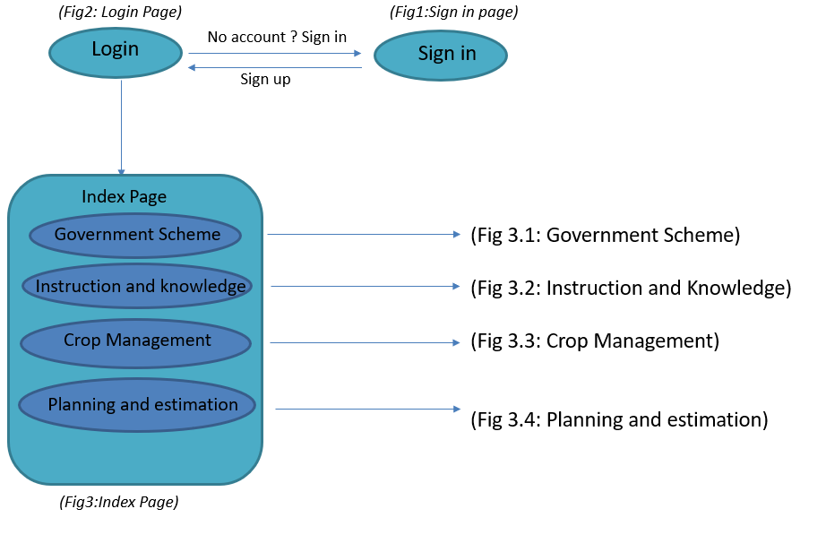

This is the basic skeletal structure of the web page along with figure numbers (which indicates another directed page of the website).

**P.T.O**

**2)Results of the page:**

***2.1) Fig1: Sign in page***



The user can sign in with their username in the ‘create username’ field as well as create the password in the ‘create password’ field. Then the user is directed to ***Fig2: Log in page***

**P.T.O**

***2.2) Fig2: Log in page***



After signing in the user needs to log in through their ‘username’ and ‘password’ in order to access the webpage. Then the user is directed to ***Fig3: Index page***

**P.T.O**

***2.3) Fig3: Index page***

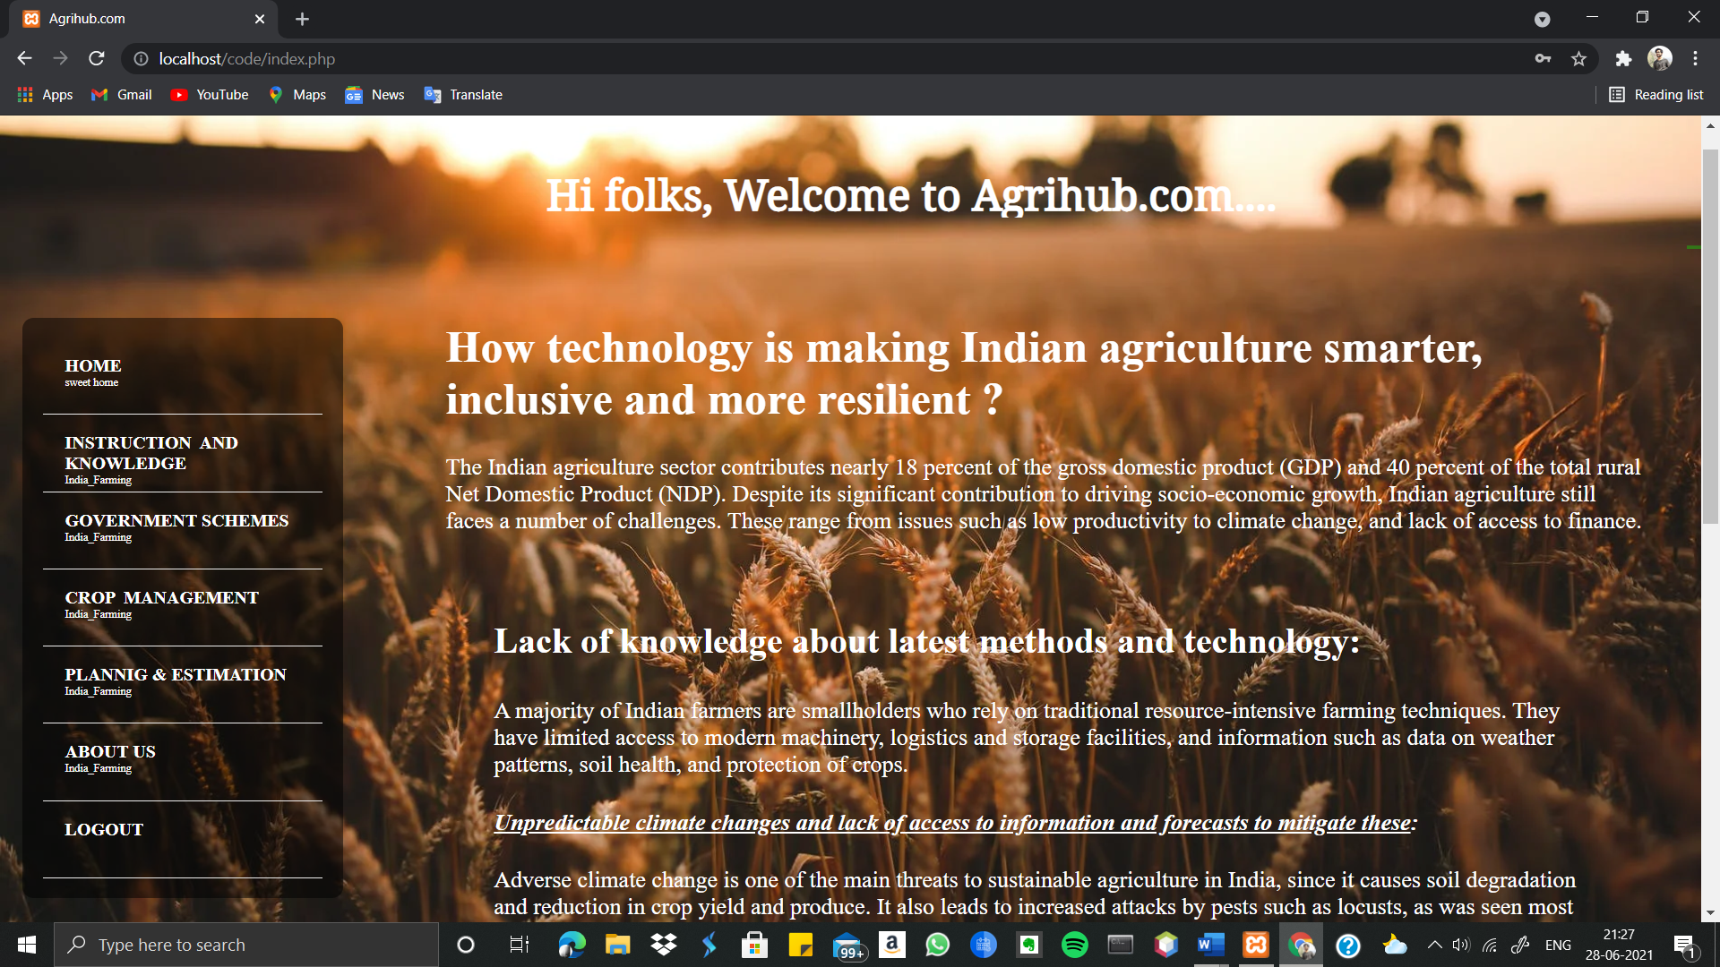

After Loging in, the user is directed to the main home page of the website where there’s a brief introduction about the web page.

*The Web page consists of a side menu which includes the following:*

**2.3.1) Fig 3.1:** Instruction and knowledge

**2.3.2) Fig 3.2:** Government Schemes

**2.3.3) Fig 3.3:** Crop Management

**2.3.4) Fig 3.4:** Planning and estimation

**2.3.5) Fig 3.5:** About us

***2.3.1) Fig3.1: Instruction and knowledge***



Instruction and knowledge comprise of four sections i.e. **FRUITS, VEGETABLES, PULSES, FLOWERS**. Selecting one of the options will direct the user to the preferred section. Here the user is provided with list of options of various crops under specified sections.

***Phase 1:*** For example: user selects the pulse option and selects the ‘Red kidney beans”. The outcome is as follows…



***Phase 2:*** After the selection of the pulse, the user is redirected to the information page of that particular crop (here, Red Kidney beans)

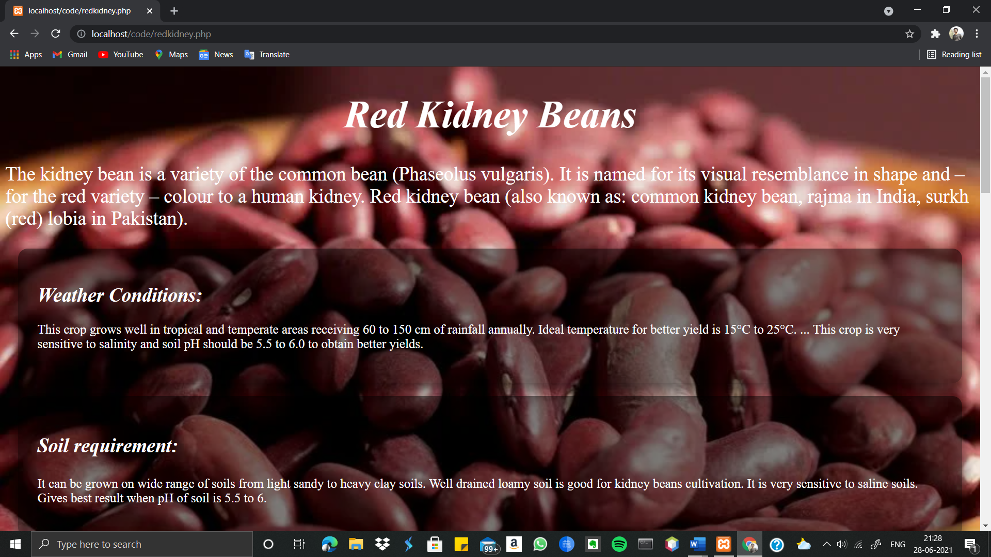

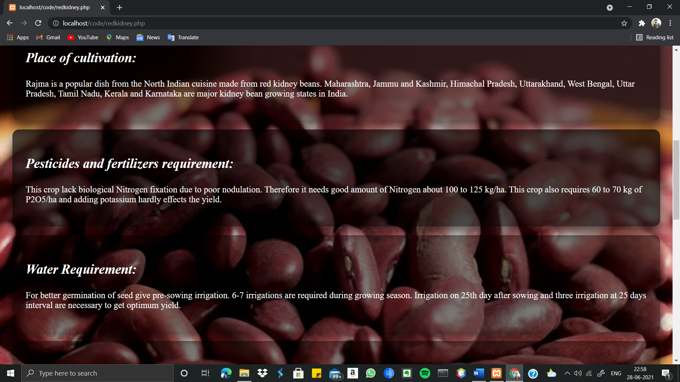

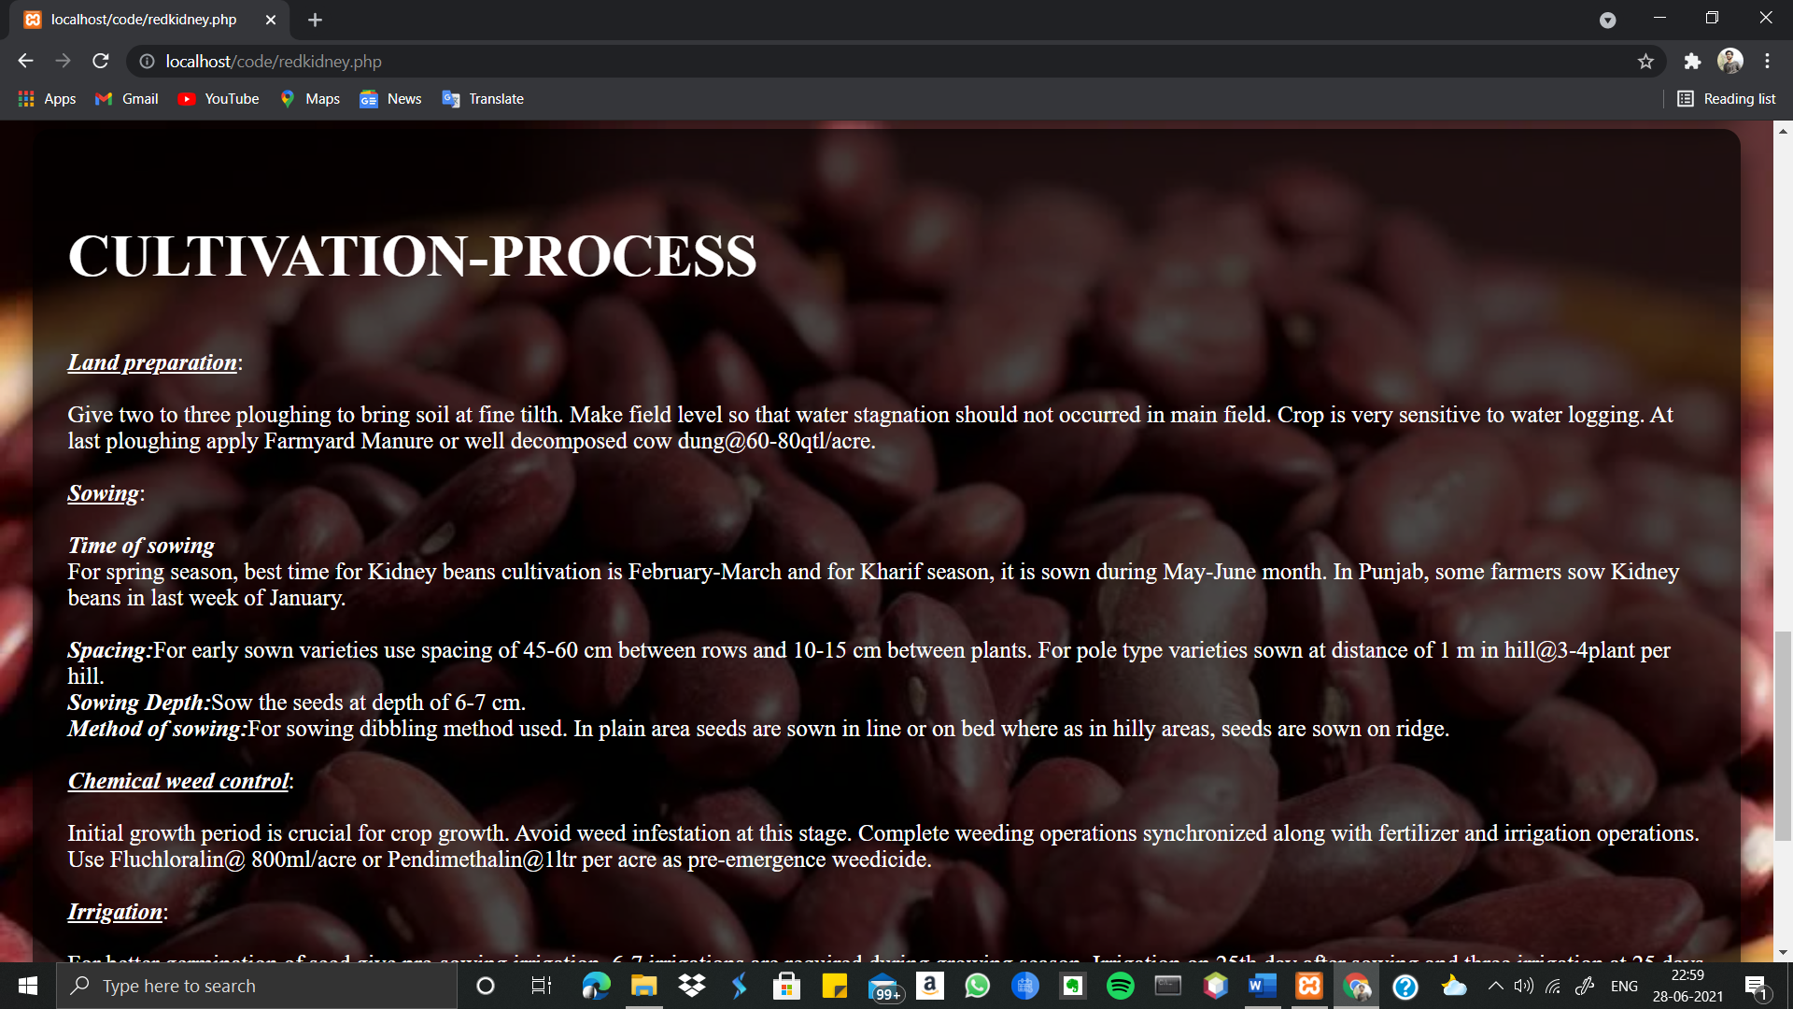

*The crops selected provides information like*

1.weather conditions

2.soil requirements

3.Pesticide requirements

4.Water requirement

5.Place of cultivation

6.Varities

7.Cultivation process

***2.3.2) Fig3.2: Government Schemes :***

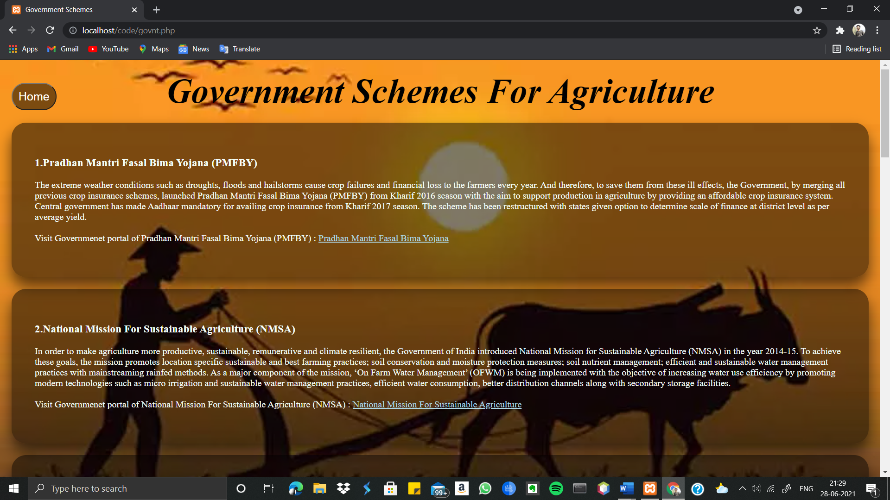

This Page provides various government schemes.

***2.3.3) Fig3.3: Crop Management :***

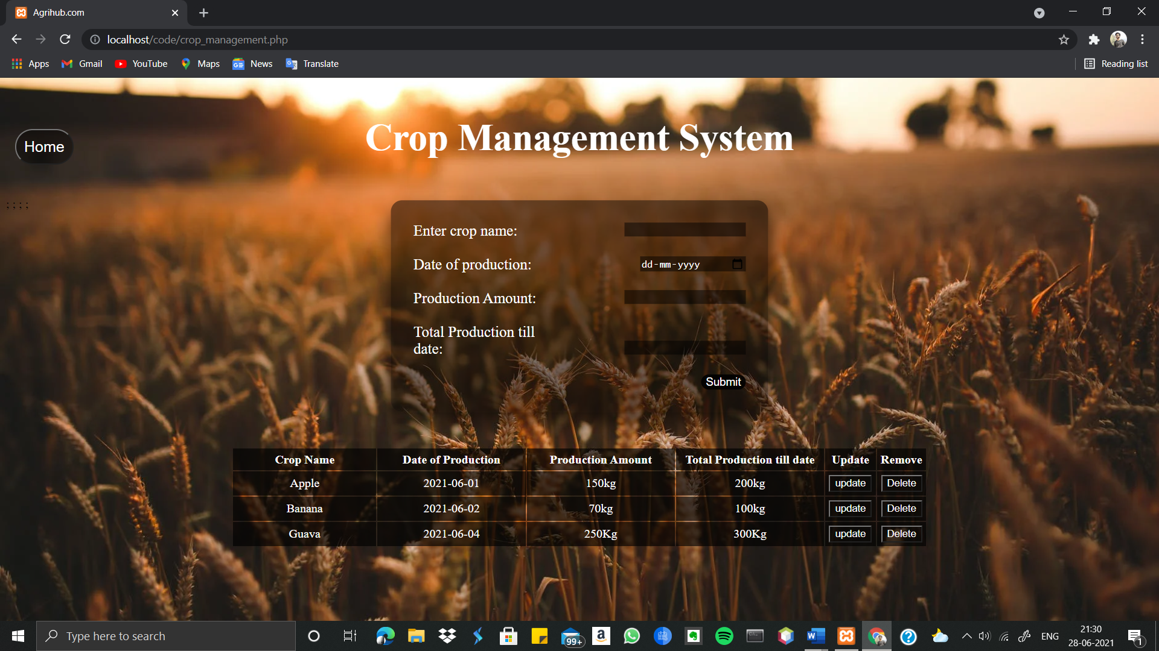

Users can store or keep a track record of the particular crops grown which can be customized according to user(i.e. update or delete the record).

***2.3.4) Fig3.4: Planning and estimation :***

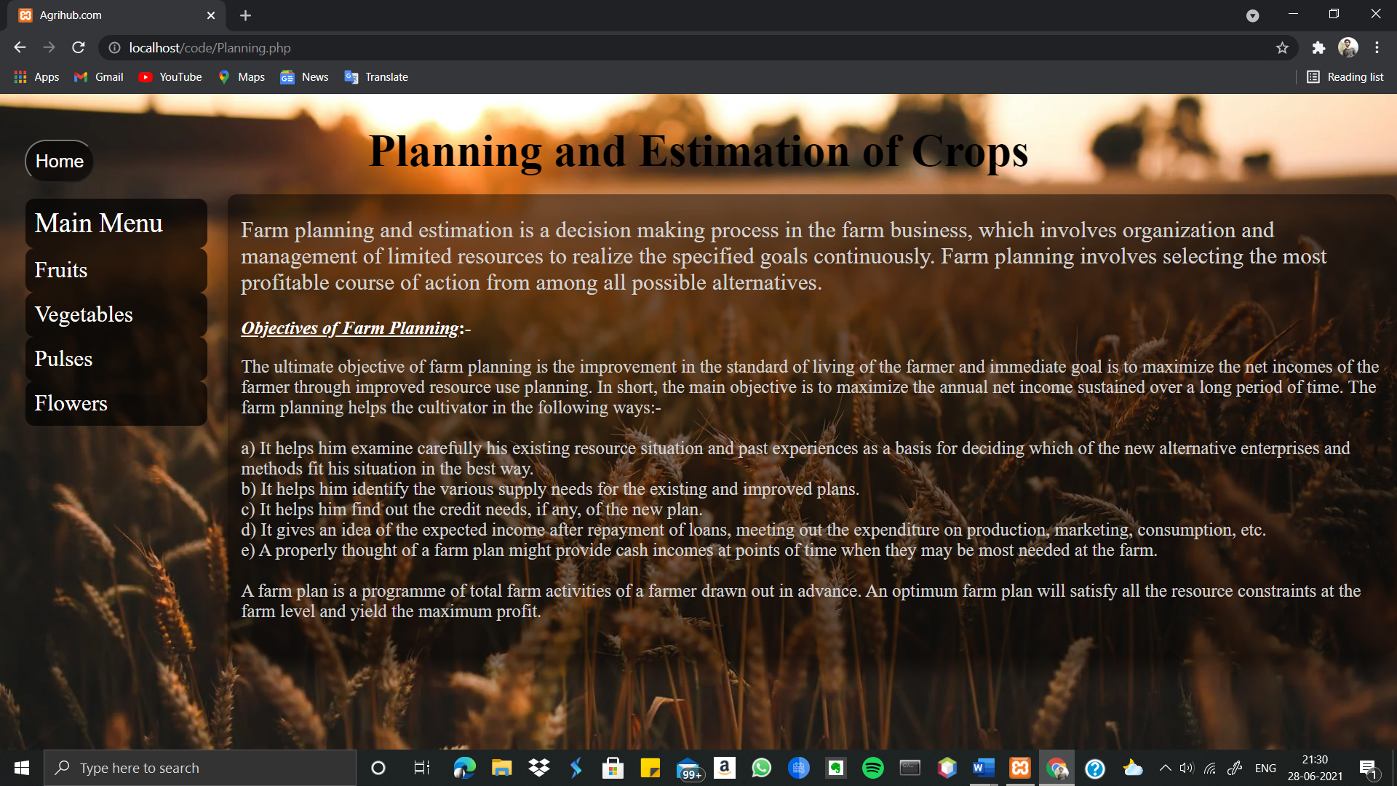

Planning and estimation play a huge role before cultivating a crop. This page guides the basic necessary planning procedures for the user to cultivate the crop. This page also estimates the amount of cultivation/hector of crops along with estimated favourable weather conditions and production time (i.e. Right from sowing seeds till harvesting).

***P.T.O***

***2.3.5) Fig3.5: About Us:***



***Log out:*** At last, we have logout option in the ***Fig3: Index page***

which will logout the user from the website.

**CHAPTER 06  :  SUMMARY AND CONCLUSIONS**

**06.1     SUMMARY OF ACHIEVEMENTS:**

             *  Team work and coordination between Team members were biggest

challenge due to this ongoing pandemic.

              *  Got to know more about different programming languages i.e.

HTML, CSS3 , JavaScript, php, bootstrap, MySQL.

              *  Easy Navigation

              * Fast – Loading

              *  Quality Content.

**06.2    Major Difficulties Encountered**

**Problems faced by farmers:**

             *  Understanding of Languages, because farmers prefer them

                   Own Regional languages.

            *   In this time of pandemic, farmers can’t gain knowledge

or get the sufficient needs in offline mode (as gathering is

not possible) for cultivation process.

**Problems faced during Developing:**

              *  Coordination between team members.

              *  Over all Designing part of project.

              * System and software requirement.

**06.3   Limitations**

            * Provided contents for limited number of crops.

            * Cultivation process are for Indian specific region (crop).

**\*** It would have been better if we could provide the

                 information in other regional languages.

* Not responsive for different hand-held devices.

**06.4   Future Scope of the Work**

              * Further establishment of the “planning and estimation “

                  page using Machine learning, Big data, IOT.

*Publication of the websites in a global server.

*Option for Regional languages selection.

* Responsive for different devices

**Chapter 07: Bibliography**

[1] GitHub,” Properties of CSS”, <https://gist.github.com/simurai/40902209f695b2d080e1>

[2] W3schools,” HTML Attributes” , <https://www.w3schools.com/html/html_attributes.asp>

[3] Stack overflow, ”Question queries” ,<https://stackoverflow.com/>

[4] Ministry of agriculture and farmers welfare - By government of India, “[AGRICULTURE, COOPERATION &](https://agricoop.nic.in/en) [FARMERS WELFARE](https://agricoop.nic.in/en)**”** , <https://agricoop.nic.in/en>

[5] Government of India, <https://www.india.gov.in/topics/agriculture>

[6] krishijagran.com, “Best Government Schemes and Programmers in Agriculture for Farmers”, <https://krishijagran.com/agripedia/best-government-schemes-and-programmes-in-agriculture-for-farmers/>

[7] Role of Information Technology in Agriculture ,[Role of Information Technology in Agriculture – OrisysIndia](https://orisys.in/role-of-information-technology-in-agriculture/), *Published year - NIL.*

[8] Indian Agriculture, farmer’s Lives and initiative by technology companies to make their lives Better

<https://www.brillinfosystems.com/blog/2019/05/29/role-of-technology-in-transforming-indian-agriculture/> , *29 May 2019.*

[9] Importance Of Technology In Indian Agriculture  [Importance Of Technology In Indian Agriculture - The    Hitavada](https://www.thehitavada.com/Encyc/2020/8/30/Importance-Of-Technology-In-Indian-Agriculture.html) *, 30 August 2020.*

[10] How technology is making Indian agriculture smarter, inclusive and more resilient. <https://yourstory.com/2020/12/technology-making-indian-agriculture-smarter-inclusive-resilient> , *10 December 2020*

[11] Applying modern tech to agriculture [Applying modern tech to agriculture (downtoearth.org.in)](https://www.downtoearth.org.in/blog/agriculture/applying-modern-tech-to-agriculture-66017) , *5 August 2019.*

[12] How new technologies can raise productivity  [How new technologies can raise farm productivity (ideasforindia.in)](https://www.ideasforindia.in/topics/agriculture/how-new-technologies-can-raise-farm-productivity.html), *6 December 2017.*

[13] How technology is making Indian agriculture smarter, inclusive and more resilient. <https://yourstory.com/2020/12/technology-making-indian-agriculture-smarter-inclusive-resilient> , *10 December 2020*

[14] Applying modern tech to agriculture [Applying modern tech to agriculture (downtoearth.org.in)](https://www.downtoearth.org.in/blog/agriculture/applying-modern-tech-to-agriculture-66017) , *5 August 2019.*

[15] How new technologies can raise productivity  [How new technologies can raise farm productivity (ideasforindia.in)](https://www.ideasforindia.in/topics/agriculture/how-new-technologies-can-raise-farm-productivity.html), *6 December 2017.*

[16] Innovations required for successful Indian agriculture in future <http://www.agrospectrumindia.com/analysis/30/180/innovations-required-for-successful-indian-agriculture-in-future.html> , 28 November 2019.

[17] Technology in Agriculture, <https://www.thestatesman.com/opinion/technology-in-agriculture-1502932835.html> , *31 October 2020.*

[18] Technology: The future of agriculture, **https://www.nature.com/articles/544S21a** , *27 April 2017.*

[19] Digitisation in Agriculture: A necessity for India, <http://www.businessworld.in/article/Digitisation-In-Agriculture-A-Necessity-For-India/27-01-2021-370573/>,*04 July 2021.*

[20]

[Latest Agriculture Technologies in India, Impact, Advantages , https://www.agrifarming.in/latest-agriculture-technologies-in-india-impact-advantages#:~:text=Higher%20crop%20productivity,into%20rivers%20and%20also%20groundwater , 25 f](Latest Agriculture Technologies in India, Impact, Advantages , https://www.agrifarming.in/latest-agriculture-technologies-in-india-impact-advantages#:~:text=Higher%20crop%20productivity,into%20rivers%20and%20also%20groundwater , )ebruary 2020.

# [21] Indian Agriculture goes Hi-Tech with New Technologies like AI, ML and IoT , <https://www.expresscomputer.in/features/indian-agriculture-goes-hi-tech-with-new-technologies-like-ai-ml-and-iot/45432/> , *January 15 2020.*